**Lesson 4 Demo 12**

**Understanding Application Configuration**



Steps to be followed:

1. Creating a static pod in the worker node

**Step 1: Creating a static pod in the worker node**

* 1. Choose one of the worker nodes. For instance we will choose worker1:
  2. Create a yaml file in worker1 node in the given path:

***cd /etc/kubernetes/manifests***

***sudo vi staticpod.yaml***



* 1. Add the following code in your yaml file:

***apiVersion: v1***

***kind: Pod***

***metadata:***

***name: static-web***

***labels:***

***role: myrole***

***spec:***

***containers:***

***- name: web***

***image: nginx***

***ports:***

***- name: web***

***containerPort: 80***

***protocol: TCP***

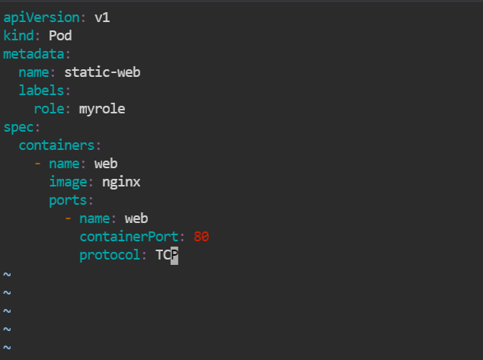

* 1. Check the status of yaml file created in master node by executing the following command in master node:

***kubectl get pods -A***

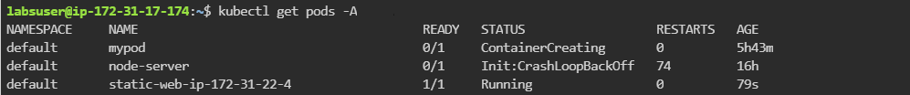

* 1. Check whether the container runs in docker by executing the following command in worker1 node:

***docker ps***

